**Sitemap & Wireframe**

* **Challenge type: Introduction, Consolidation**
* **Duration: Entire day**
* **Deadline**: end of the day
* **Team challenge** : Groups

# Objective

Before working on the final design of a website, a designer goes through several intermediate stages. We are going to see two of them today:

* The sitemap
* The wireframe

By practicing, we will see what it is for and why it is important to go through these stages.

# Definitions

**Sitemap** : A sitemap is a map of a website or application. It gives information about the organization of the website and the hierarchy between the pages.

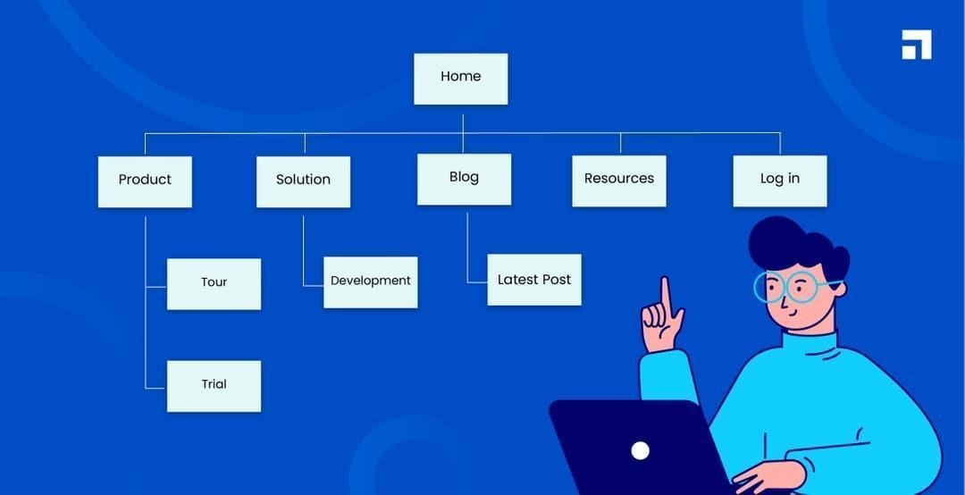

**Wireframe** : A wireframe is a basic, visual representation of a layout, without any design elements such as colors, typography, or images. It outlines the structure and hierarchy of content, as well as the placement of elements like buttons, links, and navigation. Wireframes help designers and developers to plan the layout and functionality of a website before moving on to the next steps.

# Exercise

The goal will be to redo the process used by the web designer of your favorite website…

1. Choose one website that you like
2. Create the ***sitemap*** using [Figjam](https://www.figma.com/fr/figjam/) (a tool from the Figma suite)
3. Create the wireframe of the homepage that you have selected in Figma. You can use this system for helping you [Wireframe system](https://www.figma.com/file/gGsVKYXrbnMkBV7VYz5YZx/Fugly-wireframe-design-system-(Community)?node-id=168-2105&t=keLhmk3qQBThBsXp-0)

At the end of the day, show your result to the rest of the team.

# Teams

* Team 1: * , * , * ( absent )
* Team 2: Lucas , Pietro , Ronsard
* Team 3: Antoine , Kossi , Ibrahim
* Team 4: Amandine , Yannick , Guillaume
* Team 5 : Lionel , Frank , Hichame
* Team 6 :Brieuc , Leon , Henri

# Pedagogical objectives

* Breaking down the design of a website design
* Draw drafts and transcribe them in Figma
* Work as a team on the same tool